1. Plugin:

Struture of plugin and how to create:

First, we create folder root of plugin, the name of folder is name of plugin.

Second, craete version.php, 4 lines in version file must be compulsory.

Step 3: if your plugin needs new tables in database, create install.xml file. The first time of plugin is installed in your system or change the version of plugins, the system will read this file first and execute install to database.

Note: You shuold use UI of moodle in development mode to create it easily.

Step 4: create lang\en folder and the file name that same name of plugins

This file must be compulsory, then assign at least $string[‘pluginname’] variable a value.

Note:

Every variable in this file can call by function: get_string(‘name_of_varaible’,’name_plugins’);

Like this:

get_string('manage_messages', 'local_message')

it will get the value of variable and display.

All the basic enviroment of a plugin is met, now we go to create a page of plugin to display.

Create index.php or any php file you want, the path of file to display it like a page is corresponding the url ( I mean php core).

Now, require config lib to use $DB, $OUTPUT (layout of moodle),…

We have just created a layout of page, now let move to execute interacting with DATABASE,

Create a form

Manager is main about logic and interaction of plugins with database:

How it works:

Ok, that is basic about how a plugin works.

1. Master Course

Struture of plugins:

Sequence diagram of enrol, unenrol, add course and delete course:

Database:

Details:

Every function of mastercourse plugin work in same it.

So, I concentrate on the function and logic of each function in manager.php

Now, let’s start with enrol function. (Create already).

* Explain little bit how user is enroled: 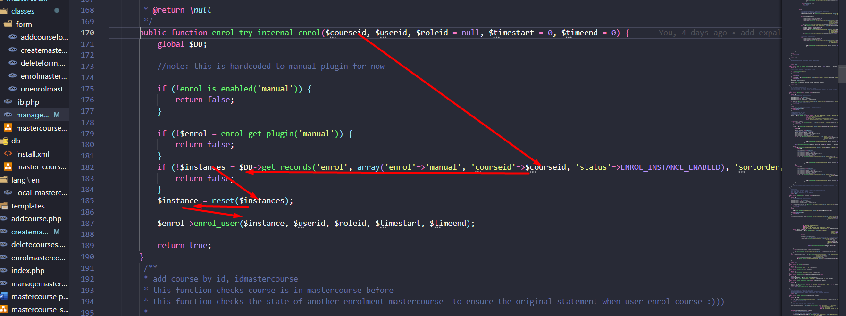

This is function from lib of plugin course. It takes the id of course and then refers to enrol state manual of this course. Then insert the enrol manaual state with id of user to mdl_user_enrolments table.

The problem here is how to enrol student to all course from mastercourse without conflict when this course student enroled before, this course in others mastercourse, then when we delete course or unenrol user from mastercourse, it is not error or lose course.

Solve: 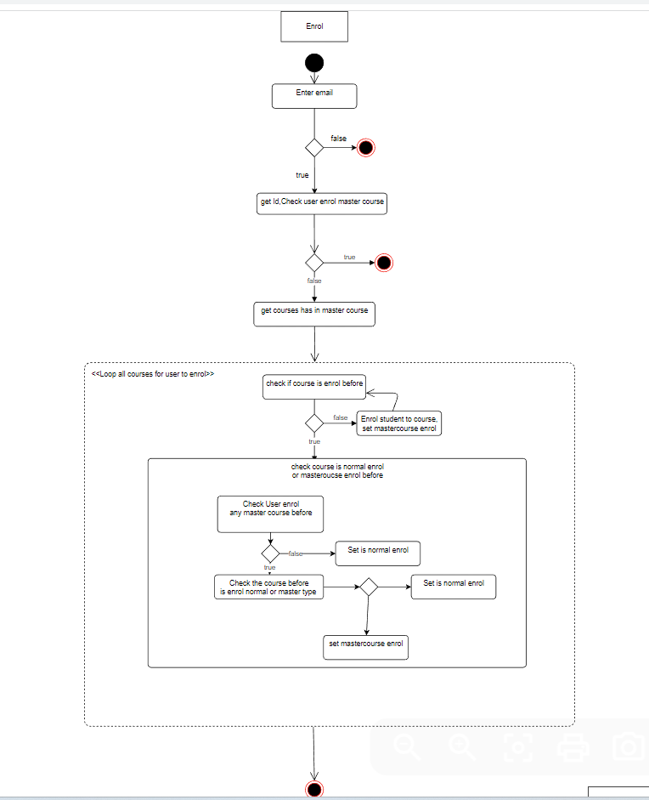

First, we enrol by email, and check that is email exist.

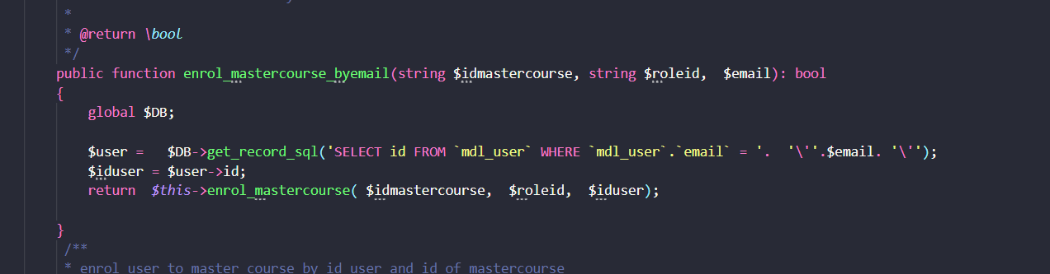

Then, check that did he enrol this mastercourse before?

If he didn’t enrol before, now, start enrol user to all course from mastercourse.

* Check user enrol course before -> fasle-> it means save, enrol user to this course and set is_normal_enrol =0; -> (it means when we unenrol this course or delete, it’s ok)
* True-> if this course user is enrol in others course which has this course -> do not unenrol user to course.

Add course.

Function: When we add course, course is added to mastercourse and all user in mastercourse is enroled new course.

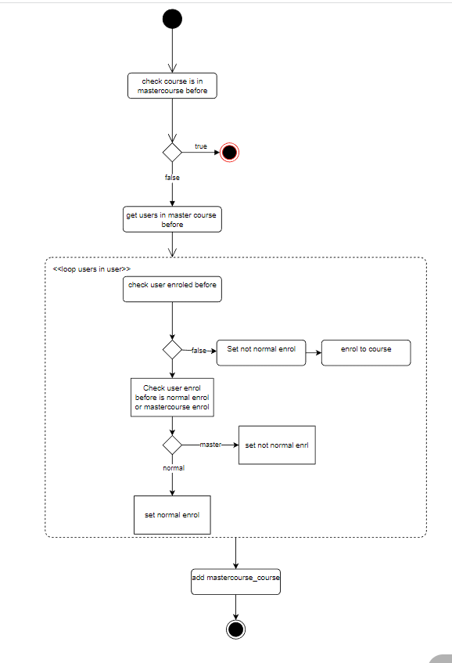

Unernol:

Function: when execute unenrol, user is unenroled all course in mastercourse.

Problem: the course which is in others mastercourse is keft and the course which at the beginning of enrol to mastercourse, it is enrol need to be keft.

Delete course

Function: when delete course, all user from mastercourse is unenrol the course deleted.

Problem: we must keep course that user is enrol in another mastercourse, or at the beginning of enrol user mastercourse, the user enrol this course the previous.

